Freemason (organization)

Freemasons are divided into various groups according to region and personality.
It is largely divided into the Scottish Light 33 class and the York Light 10 class.
They have a great impact on the world's politics, finance, business, religion, media, society, and culture,
Freemasons have a rallying place called Lodge, about 100,000 Lodges around the world.

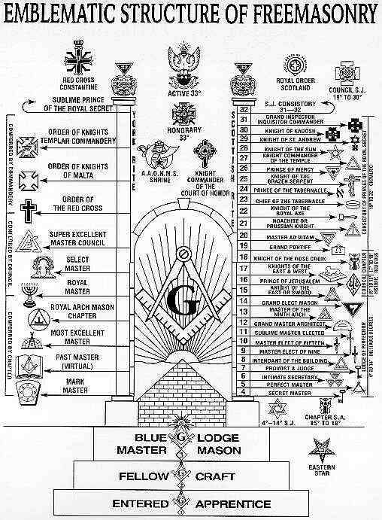

1 degree (Entered Apprentice), 2 degree (Fellow Craft), 3 degree (Master Mason) is a reserve member, and from 4 degree to become a formal member of the Secret Master Mason.
Call 33 degrees 'Grand Master' and open the council to select him the chief chairman and follow his instructions entirely

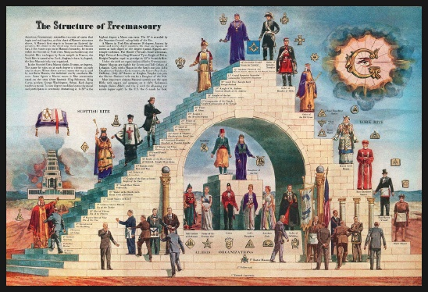

They take an unusual ceremony, covering newbie's eyes, putting a rope around he's neck, leading them into the room, putting a knife on their chest and swearing that they do not reveal secrets.
When the blindfolded eye is released, the new member will be signed to become a freemason and will be subject to a symbolic 24-inch measure and mason hammer that is said to have been used for the temple construction of King Solomon.

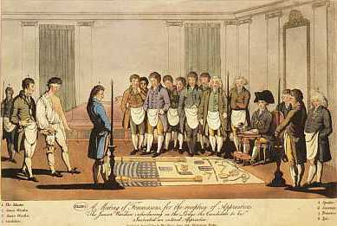
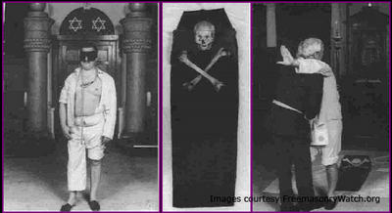

Freemasons have a secret celemony that makes their organization a fundamental religion that gives wisdom to life
In order to acquire a class, you have to learn various things and participate in the ceremony.
From the fourth stage, you will make a covenant in blood.
In order to join Freemasonry, there must have a religion, not only Christianity, but also Islam, Buddhism.

A. Local organizations
1. The Royal Institute for International Affairs (RIIA);
'The Royal Institute for International Affairs' was founded in England in 1919 and it is controls the British government and the world elite.
RIIA has an office in 'Chatham House' in Chatham Square, London.
The UK's foreign policy comes from the Chatham House.
We see that even if the United States fights against Iraq or pushes for unreasonable policies, Britain always side with the United States.
This is because RIIA in the UK and CFR in the United States are connected.
It is a research institute that seemingly holds seminars and studies foreign affairs, but major meetings are held privately by invited people.
https://www.chathamhouse.org/

2. Council on Foreign Relations, CFR
CFR was organized in 1921 as an active organization to manipulate the US government and the CIA.
Their purpose is to integrate the world's economy and to establish a world government.
CFR members will be disqualified membership if they publish the contents of the CFR meeting.
The CFR has 3,300 leaders in politics, finance, trade, telecommunications and academia as members.
CFR is influenced by J.P. Morgan, because first chairman, John Davis, was a private lawyer for J.P. Morgan.
In the United States, most political officials are CFR members, so the CFR policy maintained.
The CFR controls the American press and does what they intend to do with education and culture.
Most of presidents of the United States are CFR members because they were elected president with the help of CFR.
The chief executive and editor of the major American media are CFR members, so they create public opinion as CFR intends,
CFR promotes itself as 'a social group and Think Tank that serves the country for a good world'.
However, CFR intervened in major global conflicts that occurred in the 20th century:
Most CIA directors are from CFR, and the CIA is evaluated as agent for CFR.
http://www.cfr.org/

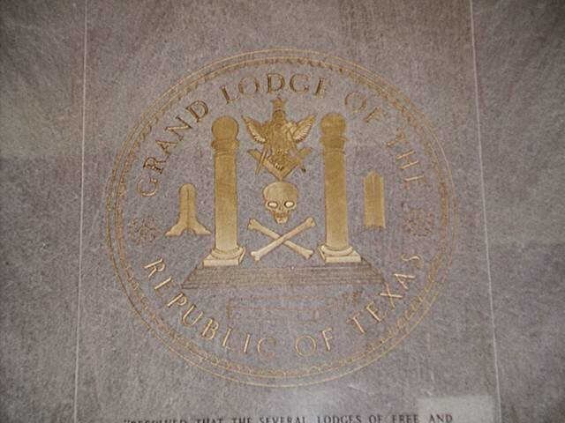

B. The highest organization
1. The Committee of 300
The Committee of 300 is a group of 300 powerful Freemason elites that move the world.
The Queen of England, is chairman and headquarter is in London and it controls all areas of the world: politics, economy, society, culture, military, religion.
The world's rich, noble, journalist, politician, and expert are members of the Committee of 300.
The Committee of 300 traditionally centered on British nobles and rich, and later accepted American rich.
The UK is dominated by 100 nobles and rich families, and the United States is dominated by the Committee of 300.
They have collected a lot of money from the British Empire through the East India Company.
The East India Company sold opium to China.
The committee of 300 has implemented several planned programs by the Tavistock Institute to promote drug proliferation in the United States.
It deindustrialization of the United States, mass-produced unemployed people, made people turn to materialism and hedonism through mass media, eventually relying on drugs.
The results are successful, with millions of American drug addicted, and most of the prison inmates are drug-related prisoners.
Drug dissemination in the United States has three purposes.
The first, is to increase the income of the committee of 300, which almost monopolizes US drug trade.
The second is to encourage social derailment and to push the fall of the United States and easily take control of the United States.
The third is to simplify humans and make them easy to deal with and to help establish a world government.
Banks in Switzerland and Hong Kong traditionally laundered and managed the money of drug.
'Hong Kong and Shanghai Bank' is still a billion-dollar payment bank from the opium trade with China..
The other source of income for the committee of 300 is from diamonds and gold mines in South Africa.

2. The Club of Rome
The Club of Rome was founded in Italy in 1968 under the auspices of the Rockefeller Foundation and is an organization that deals with the world's environment and population problems.
Their handling of environmental and population issues is to promote the legitimacy of globalization and prevent the advancement of underdeveloped countries.

3. Round Table
In the late 19th century, an Englishman named Cecil Rose discovered a diamond mine in South Africa and became rich.
He was attracted to Illuminati's world single government idea and created a 'Round table' and support.
The Rose Scholarship, named after him, draws a genius every year and studies at Oxford University.
Bill Clinton is a Rose Scholarship student.

C. sub-organisation
1. Skull and Bones
"Skull and Bones" is an elite organization and has headquartered at Yale University.
They meet at a club house called Tomb.
The skeleton and X-shaped bone symbol was originally the symbol of the Knights of Tample, and the pirates followed this.
"Skull and bones" was drug dealers, and high-ranking families like Bush and Rockefeller were members.
Since college, they joined the membership and become high-ranking social level by mutual cooperation.
The President Bush of the United States is also from Yale University's 'Skull and Bones'.
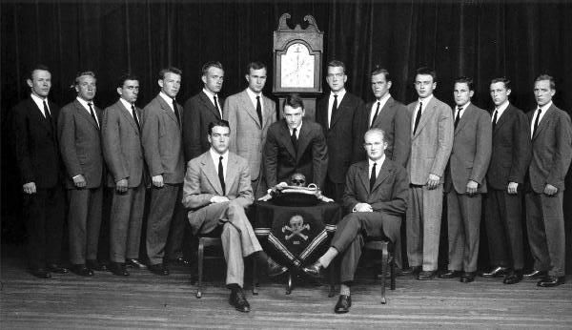

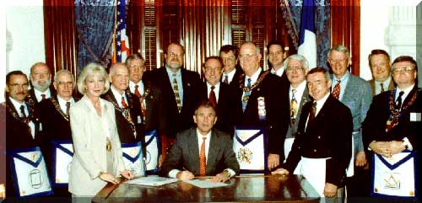

2. Trilateral Commission
The three sides of the 'Trilateral Commission' are the United States, Europe, and Asia.
;Trilateral Commission' monopolize the world economy and establish a world government.
'Trilateral Commission' was organized at the Rockefeller Mansion on 1 July 1972, sponsored by David Rockefeller.
'Trilateral Commission' has headquarter in New York, Paris and Tokyo, and is operated by executive council of 35 members.
Professor Brezinski of Columbia University is a key member of 'Trilateral Commission' and presented the ideal of establishing a world government.
http://www.trilateral.org/

3. UN
Of those who participated as U.S. representatives at the San Francisco International Conference to create the UN in 1945, 47 were CFR members.
The UN headquarters in New York was built on land donated by Freemason Rockefeller.
The United Nations was formed by representatives from 50 countries in 1945 under the leadership of CFR.
We know that the UN exists for world peace, but in reality it is an organization for the establishment of a world government.
The UN has many affiliated organizations: the World Health Organization (WHO) to reduce the world population, UNEP for economic and environmental control, and UNESCO (UNESCO) to oversee educational science and culture.

4. Bilderberg Conference
The Bilderberg Conference is a secret meeting where world political leaders from the United States and Europe, financial power elites, major media officials, and European royals attend each year to discuss international issues.
The Bilderberg Conference aims to promote globalization and build a world government.
The Bilderberg Conference was founded in 1954 by Prince Bernhard of Holland:
There was no name for the meeting, but it was called the Builderberg meeting because it was the first meeting at the Builderberg Hotel.
The decision made at the Bilderberg meeting is annouced by leaders of the G20 advanced countries.

6. Tavistock Institute for Human Relations
Here, They study brainwashing, psychological manipulation, mind control, group hypnosis, drugs, perspective, media manipulation, cultural influences.
At the time of World War II, instead of bombarding the German military plant owned by Illuminati, it caused a psychological panic by bombing the private houses of workers.
The Tavistock Institute for Human Relations is located in Sussex University and London, England.
The term "shock and fear," which emerged in the Iraq War, is also a concept long ago created by the Tabistock Institute for Human Relations, they encourages terrorism and gang murders in the United States.

D. A view of the world government ruled by the Committee of 300
The ultimate goal of the committee of 300 is to create a completely controlled totalitarian society.
The idea of a world government came mostly from 'the Clubs of Cultus Dailyboricus'
H.G. Wells who was a member of this club, released the image of the world government in his book "The Open Conspiracy: Plans for a World Revolution"
There are a few hereditary rulers, the middle class disappears, and the general public becomes slaves.
The industry is destroyed, and only the committee of 300 and the chosen elite have the right to use Earth's resources.
Limited wars, fast-paced, highly lethal diseases, famine, etc., remove the 4 billion people who waste Earth's resources and food.
The world population is limited a billion people by the ruling class, and births are limited and abortions are achieved.
Religion is allowed only one, and all Christian societies are destroyed, and demonism, Lucifer worship, and magic become the regular religion of a single world government.
Under the world government, the existing family concept disappears, and children are removed from their parents at an early age and raised as assets under the supervision of the state.
The ID number is imprinted on the body so that it can be recognized at any time, and all personal information is entered into NATO's computer in Brussels, Belgium, and can be searched at any time.
All rights of individuals are eliminated, and private property possession, possession of old money, possession of automobiles are prohibited.
All central banks except BIS and the World Bank are closed, and private banks are also banned.
Friee Sex is recommended, and pornography is forcibly shown in school classrooms or movie theaters.
It is mandatory to use recreational drugs, and it can be bought only in stores recognized by the world government by limiting the amount of drugs that go back to individuals
A drug bar run by the World Government, the slave class can spend free time there.
Brainwashing drugs are mixed in food and water without people knowing.
The non-elite public is controlled by mind control and group hypnosis, which is reduced to the same level as the beast, and is easily controlled.
Eventually, each individual is brainwashed and everyone must rely on the world government to survive.
The elites have to use such extreme methods because in order to dominate a large number of crowds without rioting or rebellion, the people must corrupt and make them easy to deal with.
If the ruling forces, who already have the wealth and power of the world, control the people with cutting-edge science and technology, it is possible enough and will encourage extreme confusion first.
Another reason elites have to do this is to keep the world in control, as the earth will be in great crisis in the future due to environmental pollution, resource depletion, population growth and food shortages.
The Christian oppression, the insertion of the mark of the beast and the forced idolatry are similar to the description of the Revelation in the Bible.
This idea came from the Demon worship club because the committee of 300 absolutely obeys the revelation of Satan given through magic.

