Freemason (Person)

Elites such as world-class politicians, rich, scientists, philosophers, and artists are Freemasons.
It is difficult to succeed if he is not a freemason because the upper class of the US and Europe is formed by the freemason.
There are about 5.7 million Freemasons worldwide, of which 5 million are in the United States.
* Famous Freemasons
a. A politician;
1. George Washington: The first President of the United States;
2. Benjamin Franklin: The author of the Declaration of Independence;
3. Franklin Roosevelt: The President of the United States;
4. Truman: The President of the United States.
5. Winston Churchill: The Prime Minister of the United Kingdom;
6. George Bush: The President of the United States.
7. Bill Clinton: The President of the United States;
8. Bob Doll: U.S. Senator.
9. Henry Kissinger: Secretary of State, CFR member, and 300 committee member.
10. Rabin: Israeli Prime Minister.
11. Queen Elizabeth II: Head of the 300 committee;

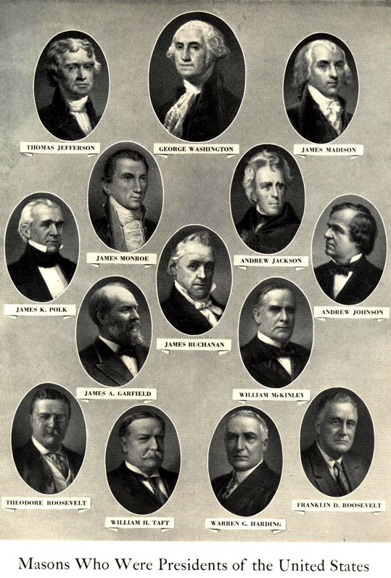

b. Rich
1. The Rothschild family: Controlling the United States and European finance, and controlling the government;
2. Rockefeller family: The oil conglomerate of the United States, and the majority shareholder of the Federal Reserve Bank.

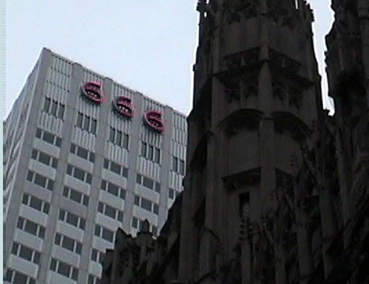
666 (Satan worship mark) neon sign hanging on Rockefeller building

3. Morgan family: Banker and contributed to the establishment of the Federal Reserve Bank.
4. Richie DeVos: Chairman of Amway, 33 degrees.
5. Bill Gates: Members of the Illuminati.
6. Walt Disney: Founder of Disneyland;
7. Henry Ford: Founder of Ford Motor Company. Father of the American Automobile Industry.
8. Chrysler: Founder of Chrysler Motor Company. The company mark is a pentagon, a Freemason symbol.
9. Carnegie: Steel conglomerate
10. Dave Thomas; Chairman of Wendy's Hamburger
11. Giuseppe Mazzini; founder of the mafia;
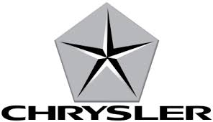

c. scientist, inventor;
1. Galileo Galileo: the heliocentric theory;
2, Einstein: Theory of Relativity
3. Jenner: a smallpox vaccine.

d. Philosopher
1. Nietzsche: The death of god
2. Karl Marx: communism
3. Rousseau: Making the basic ideology of the French Revolution as a member of the Illuminati.
4. Montesquieu; French Enlightenment, the foundation of the separation of powers;
5. Voltaire: A French Enlightenment philosopher;
6. Sigmund Freud: Psychologist
7. Friedrich Engels: German socialist
8. Bacon: philosopher, His book "New Atlantis" describes Freemason's utopia.

e. Artists
1. Leonardo da Vinch
2. Mozart: A Freemason musician who realize his mistake and tried to escape, but he was killed.
3. Beethoven
4, Haydn ; Austrian Composer
5. List: Piano, composition;
6. George Gershwin; called the father of American jazz music.
7. Louis Armstrong; Black Jazz Musician

f. Author
1. Victor Hugo; french author
2. Mark Twain: american author
3. Goethe: The contents of selling his soul to Satan, Faust.
4. Shakespeare: An English writer
5. Byron: Poets of England
6. Pushkin: A Russian poet
7. Bernard Shaw: A British novelist

g. A religious person
1. Charles Taze Russell: Founder of Jehovah's Witnesses, 33 degrees of freemason
2. Moon Sun-myung: The founder of the Unification Church , 33 degrees
3. The Dalai Lama: The leader of the Rama, 33 degrees
4. Joseph Smith jr.: Founder of Mormonism, 33 degrees.
5. Mrs. Eddy; founder of Christian sciece, 32 degrees.
6. Ron Hubbard; founder of the Cyontology, Illuminati
7. Billy Graham: Reverend, 33 degrees.
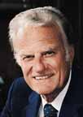
8. Jash Jackson: Reverend and Democratic Senator, 33 degrees of Freemason.
9. Norman Vincent Phil; Rev., religious pluralist, 33 degrees of Freemason
10. Robert Schuller ; Reverend Crystal Church, 33 degrees of Freemason.
